**Effect of Sound on the Marine Environment (ESME) Workbench**

**11 March 2011**

**User Manual**

System Requirements: Windows 7 operating system

1. Uninstall the previous version of ESME workbench
2. Create the following directories on the local computer.
   1. ESME_program_files
      1. This will store the installation setup file and most of the program files to run ESME
   2. ESME_data_files
      1. This will store all of the input files necessary to run experiments in any version of ESME
   3. ESME_experiments
      1. This will store the *.esme file for each specific experiment run in the ESME workbench.
      2. The *.esme file contains the paths to the input data files and the location of analysis points in the experiment.
      3. Folders will also be created in the same directory as the *.esme file which contain the output files (*.tlf) from the transmission loss (TL) calculations. (These folders are hidden.)

NOTE: The directories can be anywhere on the local hard drive, but this basic directory structure is recommended to keep the input/output and program files organized when running and/or update the ESME Workbench. Likewise, the directories do not have to have these specific names, but these names will be used throughout this document.

1. Download installation and data files from the Boston University (BU) website
   1. <http://esme.bu.edu/team/>
      1. Login: esme
      2. Password: onr
   2. Download the installation setup file to the ESME_program_files directory
      1. ESME WorkBench Setup.msi (located in the “Phase 1 Iteration 4” directory)
   3. Download the following files to the ESME_data_files directory
      1. ESME Environmental Data.zip
      2. Scenario Builder 1.5.508.zip
      3. jax3species.zip (located in the “Phase 1 Iteration 4” directory)
      4. Unzip each of the above folders within the ESME_data_files directory, and delete the .zip files
2. Install the ESME software
   1. Navigate to ESME_program_files directory and run ESME WorkBench Setup.msi
   2. Set the program installation directory to ESME_program_files
3. Start ESME Workbench
   1. Double click on the ESME workbench 2010 shortcut to start ESME

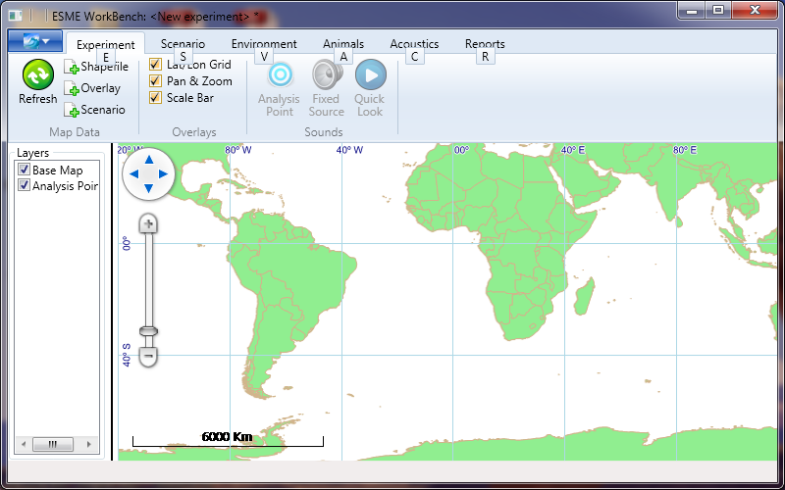

* 1. Beware of display issues in this version:
     1. Changing window size may create map display artifacts. Subsequently zooming in/out will remove them.
     2. Areas of the menu bar or layer display pane may be blacked out. They will usually clear up by moving the mouse over the black areas.

1. Set up and save an experiment
   1. Select “Options” from the drop-down box in the upper left corner of the ESME window
      1. Scenario tab
         1. Set the Scenario Editor Executable File to scenario-builder.jar in the ESME_data_files\Scenario Builder 1.5.508 folder.
         2. Set the Scenario Editor data directory to the Sim Area folder in the ESME_data_files\Scenario Builder 1.5.508 folder.
         3. 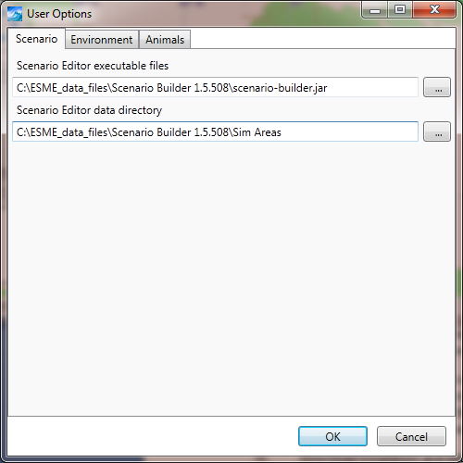
      2. Environment tab
         1. Set the Environment database directory to the\ESME_data_files\ESME Environmental Data folder. This folder contains the bathymetry, bottom properties, and sound speed profiles.
         2. 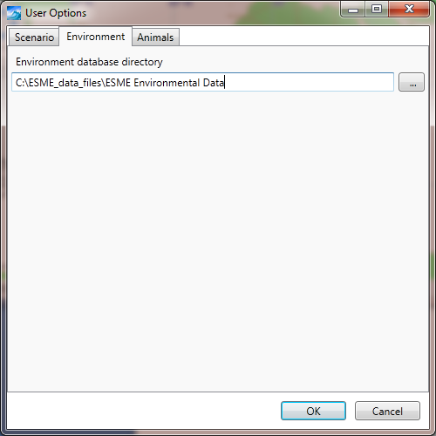
      3. Animals tab
         1. Set the path to the JAX3species.sce file in the \ESME_data_files folder. This file was created with 3MB and contains the marine mammal locations.

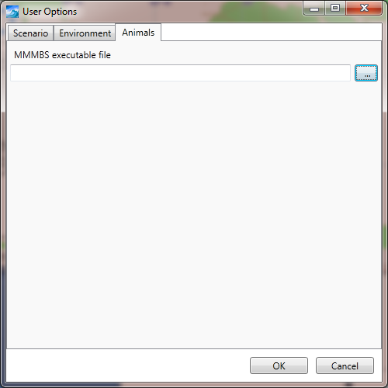

* + 1. Click OK
  1. Load a scenario file from the Atlantic Ocean near Jacksonville, FL. This file was created with the Scenario Builder and contains all of the sound source information for simple scenario.
     1. Select the “Scenario” tab and click “Open”.
     2. Select the JAX Small.nemo file in the \ESME_data_files\Scenario Builder.5.508\Jacksonville folder.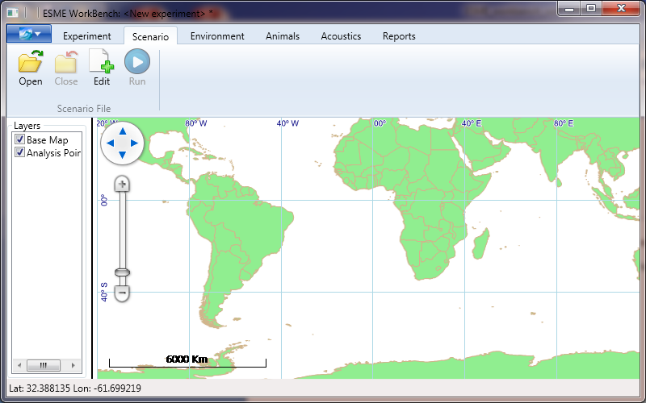
     3. The map layers for two operating areas and ship tracks appear on the screen. Pan and zoom to the East coast of Florida, as shown below.

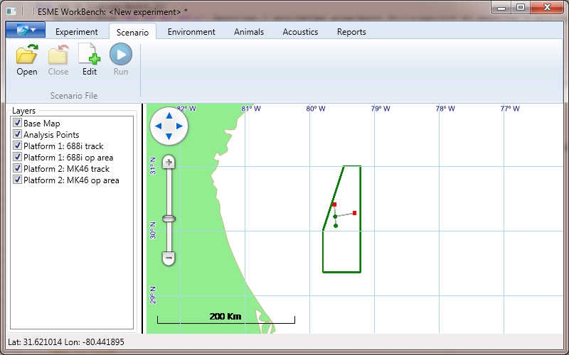

* + 1. The operation areas are shown as a dark green polygon. (In this example, the operating area for both platforms is the same). The display for each operating area can be turned on/off by checking/un-checking the box next to the “Platform 1: 688i op area” or “Platform 2: MK46 op area” in the Layers box to the left of the map.
    2. The 688i track (Platform 1) runs along the gray line from South to North; beginning at the green circle and ending at the red square. Likewise, the MK46 track (Platform 2) runs along a horizontal gray line in a NE direction. The display for each track can be turned on/off by checking/un-checking the box next to the “Platform 1: 688i track” or “Platform 2: MK46 track” in the Layers box to the left of the map.
    3. Note: Turning the map display for a track on/off does not impact the sources used in the TL calculations. The operating area and track displays only provide a guide when selecting analysis points for the TL calculations.
  1. Define the environment Settings
     1. Click on the Environment tab, and then click Settings in the upper left corner.

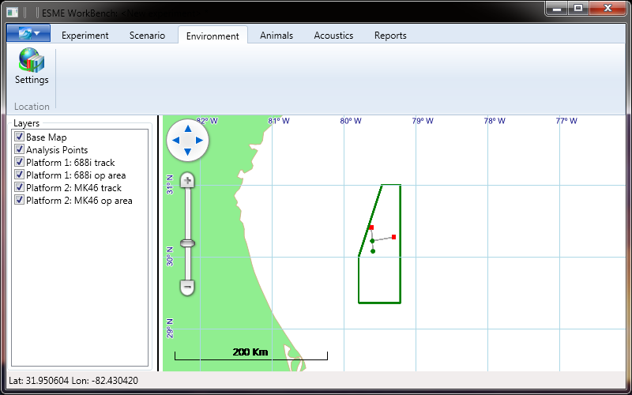

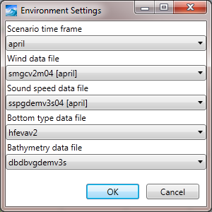

* + 1. Select the environment settings from each of the drop-down lists. (This specific example will use the default settings).
    2. Click OK
  1. Save the experiment
     1. Select “Save Experiment As” from the drop-down box in the upper left corner of the ESME window
     2. Navigate to the \ESME_experiments folder.
     3. In the Filename box type a file name for this experiment, e.g. “JAX_experiment_1.esme”
     4. Click “Save”. The setup information for the experiment is now saved.
  2. Close the experiment
     1. Select “Close Experiment” from the drop-down box in the upper left corner of the ESME window
     2. The map window zooms out to the world map, and the Platform tracks and operating areas are removed from the display layers.

1. Acoustic Propagation
   1. Open the experiment that was just created.
      1. Select “Open Experiment” from the drop-down box in the upper left corner of the ESME window
      2. Navigate to the \ESME_experiments folder.
      3. Click on the “JAX_experiment_1.esme” file and click “Open”.
         1. The map window zooms back to the last view that was used before the experiment was saved. The Platform tracks and operating areas are again visible as display layers.
         2. All the file path settings for the input data files are restored, and ESME workbench is ready to run an analysis.
   2. Run a Quick Look analysis
      1. Click on the Experiment tab
      2. Click on the Quick Look button
         1. The mouse cursor now turns into a cross hair.
         2. In the map window, click on a point near the end of the MK46 track (red square at the end of the gray horizontal line). 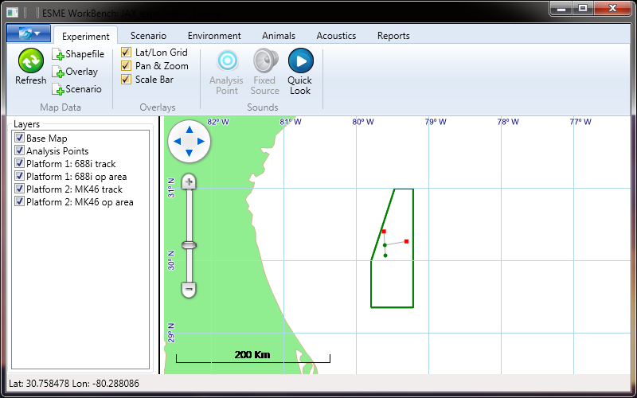
            1. The Analysis Point View window opens up showing each of the modes for each platform in the experiment. 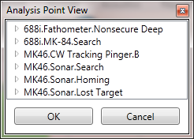
            2. Double-click on the “688i.Fathometer.Nonsecure Deep” mode of the 688i platform to see the source settings that will be used.

Settings that are in white may be edited.

For this example, source settings will not be edited.

Note, that all of the modes for all of the platforms will be run at these coordinates. Future versions of ESME WORKBENCH will allow more flexibility in selecting the active modes.

Double-Clicking on other modes will open their settings. 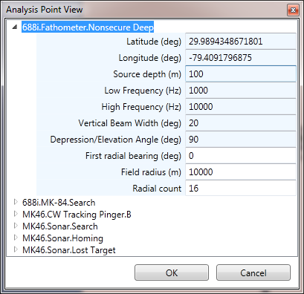

Double-Clicking on an open mode name will minimize the list of options for that mode.

Click “OK” to begin the analysis

The Bellhop Queue Calculator View window opens.

The Queue window shows the TL calculation status of each of the modes.

Double-Click on the first mode to see the TL calculation status of each radial.

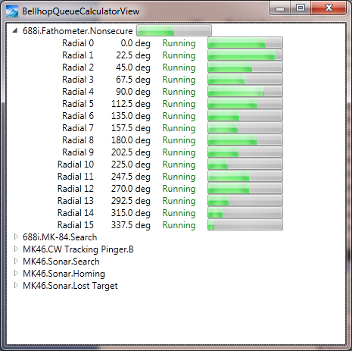

The mode name will disappear from the list when its TL calculations are finished.

The Queue window will close automatically when all of the calculations are finished.

Do not close the Queue window while the calculations are running. This will stop the calculations and cause ESME to become unstable. ESME will shut down when attempting to run another Quick Look calculation, unless ESME is restarted.

When the analysis is completed, the map window will show a green marker at the location of the sources.

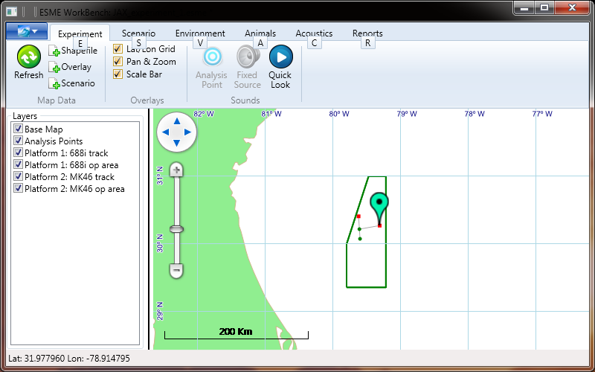

1. Animat Population.
2. Run a Full Simulation
   1. With an open, full experiment for which analysis points and/or quick looks have been computed:
      1. In the Scenario tab on the ribbon control, click “Run”.
      2. A popup opens, displaying the runtime parameters and a file dialog location to save the generated report.
      3. Once the simulation is complete, the file specified will have binned exposure data for all species and sources.

**Appendix A: Configuration of OAML Environmental Databases**

The environmental data used by ESME Workbench to generate transmission losses is provided by four Oceanographic and Atmospheric Master Library (OAML) Databases:

1. The Re-Packed Bottom Sediment Type Database, Version 2.0 (BST)
2. The Digital Bathymetric Database – Variable Resolution, Version 4.5U (DBDB)
3. The Generalized Digital Environmental Model – Variable Resolution , Version 3.0.1 (GDEM-V)
4. The Surface Marine Gridded Climatology Database, Version 2.0 (SMGC)

These databases are available on a variety of compact disc media, and may be provided as part of the ESME Workbench software suite as a collection of compressed files.

Each of the four OAML databases are subtly different and must be configured differently. Each database requires the use of a) a database extraction program and b) the database itself. What follows is a description of both attributes for each database.

1. BST
   1. Extraction Program

The BST extraction program is named ‘extract.exe’, and is located on the OAML CD at the path

“Sediments2.0_QAV_Analysis\Sediments\Version2.0\tools\Windows\with_hdf5_1.6\extract.exe”

The extraction program should be copied to disk, and its location configured in the ESME Workbench options dialog.

* 1. Database structure

The BST Database is provided as a HDF5 file on the OAML CD, “Sediments2.0_QAV_Analysis\Sediments\Version2.0\databases\hfevav2.h5” and may be copied locally. Its location is configured in the ESME Workbench options dialog.

1. DBDB
   1. Extraction Program

The DBDB extraction program is located on the OAML CD at the path “bin\Windows\dbv5_command.exe”

* 1. Database structure

The DBDB Database is provided as a HDF5 file located on the OAML CD at “data\dbdbv5_level0c_0.h5” and should be copied locally.

1. GDEM-V
   1. Extraction Program

The extraction program for GDEM-V is provided as a standalone application that is bundled with ESME Workbench.

* 1. Database structure

The GDEM-V database is a collection of gzipped NetCDF files that are provided on 4 CDs. CD 1 contains 12 files named “tgdemv3sXX.nc.gz”, where XX ranges from 00 to 12, and correspond to calendar months JAN-DEC, respectively. ‘T’ denotes ‘ temperature’. CD 2 contains 12 files named “sgdemv3sXX.nc.gz”, where XX again ranges from 00 to 12, and ‘S’ denotes ‘salinity’. These 24 files should be decompressed and placed in a single directory, and the location of this directory specified in ESME Workbench’s Options dialog.

1. SMGC
   1. Extraction Program

The source code for the SMGC extraction program is provided on an OAML CD. The compiled version for windows operating systems is provided with ESME Workbench, and is located in the default installation directory, and named SMGC_Extract.exe.

* 1. Database structure

The SMGC database consists of 64,800 files of the form “[n,s]XX[e,w]YYY.stt”, where XX specifies the latitude and YYY the longitude, in degrees, of the 1 degree of the globe that that file contains information for.

These files are spread across discs 2-5 of the OAML CDs. They should all be copied into the same directory on the local hard drive, and that directory’s location specified in ESME Workbench.